## Organisation Hierarchy

This controls access to contact records and determines how the organisation is structured. It also used to control the licensing of the product. This is available from within Adviser Evolution under the security application.

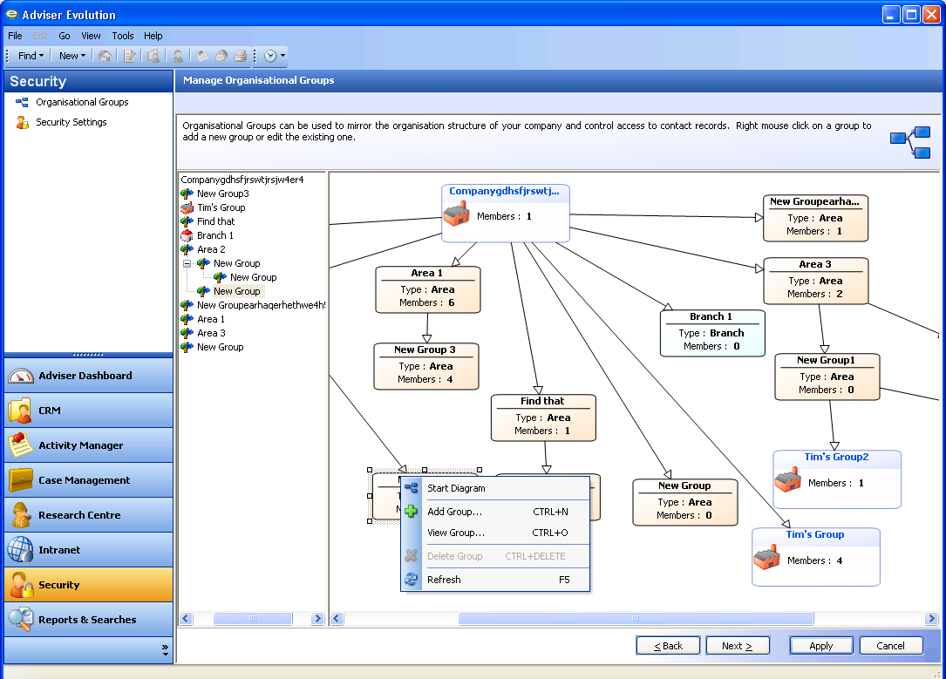

## Security Settings

The current security setting with the system is geared towards a true smart client. The ability to back up your local database and schedule local tasks are included here. I am using an account with administrator privilege which is allowing me to see more options.

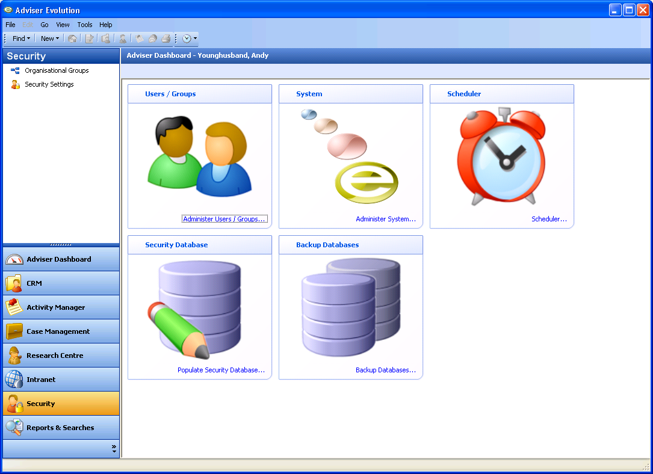

## Users and Groups

There is a very simplistic interface to administer users and groups as this is meant to be a framework for any application. Application specific extensions to this security can be maintained in the application themselves. In Adviser Evolution we maintain advisers in the system that link back to this basic security but extend it by adding in additional information like Competency, Contact details etc...

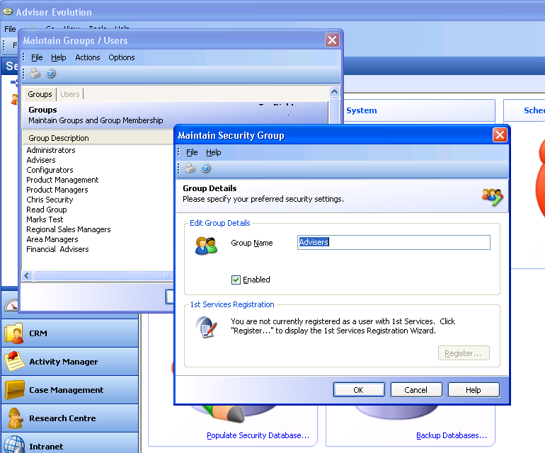

## Application Configuration (Group Rights)

A Groups rights to the system can be configured using the Administer System option

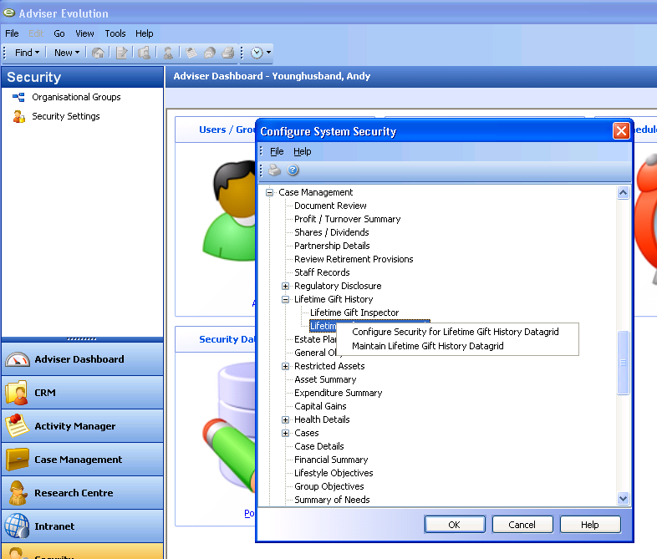

More intuitively you can configure Adviser Evolution by running it in Configuration mode and actually using it to configure itself:

